

**Head of Visitor Engagement**

**Candidate Briefing Pack**

**May 2025**

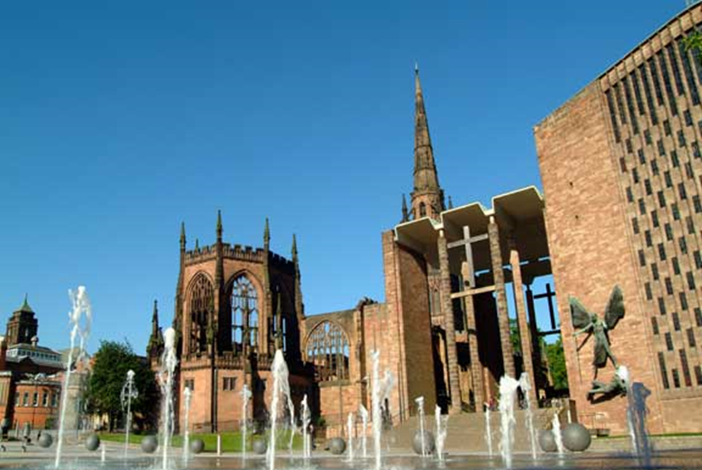

**Contents**

**Background from the Dean**

**Job description**

**Person specification**

**Guidance on completing your application**

**Privacy notice and dealing with personal data**

Dear Applicant,

Thank you for your interest in applying for the post of Head of Visitor Engagement at Coventry Cathedral. This is an exciting post that builds upon the arrival of our Canon for Worship and Welcome as we look to help our visitors to understand our story more thoroughly and to take away with them the hope that comes from embracing the ideas of peace and reconciliation.

**Context**

Coventry Cathedral is a living breathing space which welcomes worshippers, tourists, audiences and school children daily from near and far, either visiting or looking for place of sanctuary. With daily worship, and events taking place all year round, a busy tourist offer and a thriving education programme, all housed in the building coined “new cathedral” built in 1962. The Cathedral is also custodian of its predecessor- a 14th century building, destroyed and ruined in the Blitz during Nov 1940. The site and story have risen to international recognition, becoming a symbol and example of reconciliation. Both the new and Ruined Cathedral are grade 1 listed.

**About Us**

The Cathedral team is made of approximately 35 permanent members of staff and a growing team of volunteers. With a broad variety of specialisms within the team we pride ourselves in working across these together to meet the various challenges which we face. To help you understand more about us, I have listed our strategic objectives and values below. I hope they will give you a flavour of us as an organisation.

**Our Strategic Aims**

* *To be an open building that welcomes all people*
* *To have high quality and diverse opportunities for worship*
* *To be a local, national and international leader in reconciliation*

*These are delivered through a set of priorities:*

* *To see the Cathedral embedded as the spiritual heart of the city and diocese; as a place where people are reconciled to one another and to God*
* *To see the potential of our people released to share in the ministry of reconciliation*
* *To see our engagement with visitors shaped to focus on our reconciliation story*
* *To see exciting arts and events commissioned which further the journey towards reconciliation*
* *To see the Cathedral’s reconciliation networks developed to foster reconciliation locally, nationally and around the world*
* *To see the Cathedral’s journey progressed to becoming net-zero, reconciling us to the earth*

**Our Values**

**Hospitality** – of both people and ideas

**Faith** and **Spirituality** – being open to the challenge and resources of God

**Art** and **Creativity** – expressing the life of God amongst us in ways beyond words

**Risk Taking** – confidently stepping out of the familiar in the service of God

**Excellence** – always reaching beyond our present practice and experience

**Community** – respecting and caring for one another

We are seeking someone who is in sympathy with our ethos as a Christian organisation at the heart of this great City. You do not need to be a practicing Christian. Our values drive and shape us and if you feel you could bring your skills, experience and expertise to help us achieve our vision and deliver our values, then we would love to hear from you.

I hope you find this information useful in preparing your application.

The Very Reverend John Witcombe MA MPhil

The Dean of Coventry

**Job Description**

**Job Title:** **Head of Visitor Engagement**

**Hours:**  21 hours – days and times flexible to be agreed with job holder

**Salary:**  £18,415 (for 21 hours)

**Reporting to:** Canon for Worship and Welcome

**Work base:**  The Cathedral and its offices

**Date of Issue:** May 2025

***Aim***

1. To increase visitor numbers to the Cathedral.
2. To implement the key themes of the Cathedral’s Interpretation Strategy.
3. To improve the overall visitor experience.
4. To increase the commercial revenue of the Cathedral.

***Job Purpose***

1. The ongoing curation of appropriate materials that engage our visitors in order to educate, inspire, and encourage a response.
2. To generate an agreed annual target of income from visitors.
3. To manage the Cathedral shop, Welcome Desk, Tower climb and Blitz Museum.
4. To manage the Welcome Team Supervisor and Team Members, and key volunteers.
5. In conjunction with the Welcome Team Supervisor, to liaise with the Cathedral’s shop merchandise suppliers, to achieve excellent quality and improve spend per head.

***Responsibilities***

**Delivery**

1. To develop resourcing and delivery of the visitor experience in line with the Cathedral’s ministry of peace & reconciliation.
2. To ensure staff and volunteers understand, and can communicate, the visitor journey through the building.
3. To work closely with the Head Verger and the Head of Arts & Events in order to present a professional Front of House operation.
4. To liaise with the Education team regarding school tours.
5. To oversee the management of the tourism volunteers.
6. To analyse performance and obtain feedback from visitors, staff and volunteer tour guides with a view to improving the efficiency of delivery and enhancing the customer experience.
7. To be aware of the range of people that visit the Cathedral and to take into account the varying needs of our visitors, including potential safeguarding needs.

**Sales / Key Account Management**

1. To oversee and actively pursue promotion of the Cathedral as a tourist destination through building new relationships, both B2B and B2C, and strengthening the loyalty of existing tour groups.
2. To develop the gift shop and Welcome Desk to obtain maximum sales potential, including seasonal sales promotions.
3. To secure a sustainable programme of high value group tours for the medium and long term.
4. To research new opportunities and set short and long term sales goals to increase business.
5. To produce appropriate information on charges and facilities for potential visitors.
6. To deliver clear and comprehensive management information for internal use.
7. To oversee budgets, to develop and maintain client business records, to analyse revenue and to forecast business.
8. To represent the Cathedral at city, regional and national industry events.

***Other***

To carry out such other tasks as may reasonably be required within the capacity and experience of the post holder, as may be relevant to the purpose and needs of the Cathedral.

***Accountability and Supervision received***

The post holder will be accountable to the Canon for Worship & Welcome.

The Head of Visitor Engagement will be responsible for the Welcome Team Supervisor and the Welcome Team, both staff and volunteers.

***Terms and Conditions***

* You will be working 21 hours per week with occasional weekends and evening work required. The Cathedral operates time off in lieu for extra hours worked.
* A starting salary of £18,415 and 8% employer contribution pension scheme will be available after successful completion of the probationary period of 6 months.
* 27 days annual leave plus 8 public holidays, pro rata. The Cathedral has a documented Time Off In Lieu policy.

**Person Specification**

|  |  |  |  |
| --- | --- | --- | --- |
|  | **Essential** | **Desirable** | **Evidenced through** |
| **Interpersonal** |  |  |  |
| Warm and friendly demeanour – willingness to help | X |  | Interview |
| An understanding of the need to engage with people of all faiths and none | X |  | Interview |
| **Experience** |  |  |  |
| Evidence of a creative approach to engaging visitors in a public space | X |  | Application and interview |
| Demonstrable business flair and previous experience of working in a customer-focused environment | X |  | Application |
| Previous experience in a tourism and leisure environment | X |  | Application |
| Experience of managing staff and /or working with volunteers |  | X | Application and interview |
| Using MS Office to a good standard |  | X | Application and interview |
| Operating efficient systems to manage information – filing, record keeping etc. | X |  | Application and interview |
| **Knowledge** |  |  |  |
| Understanding of the Church of England and the Cathedral environment |  | X | Application |
| Understanding of the history of Coventry and the position of the Cathedra within it |  | X | Application |
| Awareness of safeguarding priorities |  | X | Application |
| **Skills** |  |  |  |
| Organised and structured to ensure activity timescales are met | X |  | Application and interview |
| Clear communicator in person and on paper | X |  | Application and interview |
| Willingness to contribute ideas and follow through to delivery of solutions | X |  | Application and interview |
| A self starter able to work closely and co-operatively with colleagues as a member of a small team | X |  | Application and interview |

**Guidance on completing your application**

All vacancies are accompanied by a job description and a person specification. The job description sets out the main duties and responsibilities of the post, and the person specification details the knowledge, skills and abilities we are looking for.

To apply for the post please send us a copy of your CV along with a covering letter of a maximum of 2 A4 pages telling us how you meet the criteria set out in the Person Specification. The covering letter is your opportunity to provide all the information we need to help us understand how you meet the requirements of the job, and plays an important part in the selection process allowing us to short-list candidates for interview and helping as a basis for the interview itself. Please use the covering letter to demonstrate how you meet the essential and desirable requirements of the person specification. Applications without a covering letter will not be shortlisted.

To ensure fairness to all applicants, short listing decisions are based solely on the information you supply on your CV and covering letter. Even if we already know you as current or previous employee, it is important that you complete the application process in full.

Please ensure your CV lists two references. One of these should be from your current (or most recent) employer.

Depending on the number of applications, it may not be possible to shortlist for interview all candidates who meet the Essential Criteria.

Please e-mail, your CV and covering letter to **office@coventrycathedral.org.uk** (please use the job title as the subject of the email), or send it by post to **Recruitment, Coventry Cathedral, 11 Priory Row, Coventry, CV1 5EX.**

Ensure you clearly state the full job title to which you are applying.

All applications must reach us on or before the closing date which is 12 Noon on Monday 16th June.

**Interviews**

Interviews are provisionally scheduled Thursday 26th June.

**Data Protection**

Information provided by you as part of your application will be used in the recruitment process. Any data about you will be held securely with access restricted to those involved in dealing with your application and in the recruitment process. Once this process is completed the data relating to unsuccessful applicants will be stored for a maximum of 6 months and then destroyed. If you are the successful candidate, your CV and cover letter will be retained and form the basis of your personnel record. By submitting your CV you are giving your consent to your data being stored and processed for the purposes of the recruitment process, equal opportunities monitoring and your personnel record if you are the successful candidate.

**Work Permits**

Under the Asylum and Immigration Act, we are required to check that anyone taking up employment with us has the legal right to work in the UK. Short-listed applicants will be asked to provide us with documentary evidence to support their entitlement to work in the UK prior to any offer of employment being made.

**References**

In the event of an offer of employment being made, we will take up references and reserve the right to validate all information entered on the CV.

**Questions?**

If you have any questions or queries, please contact Rev. Canon Nitano Muller on 024 7652 1225 or email nitano.muller@coventrycathedral.org.uk.

**Job Applicant Privacy Notice**

**COVENTRY CATHEDRAL** (‘we’ or ‘us’) provide this notice to make job applicants aware of our policies relating to the processing of personal data in accordance with the Data Protection Act 1998 as amended, replaced, re-enacted or consolidated from time to time (including without limitation the General Data Protection Regulation (EU) 2016/679 and any national laws which relate to the processing of personal data (‘Data Protection Legislation’)) references to ‘Personal Data’ and ‘Sensitive Personal Data’ within this notice shall be references to those terms as defined in Data Protection Legislation.

**Personal Data**

We ask for Personal Data from job applicants including CVs and any ancillary information provided as part of your application to assist with our recruitment processes. Any Personal Data about you which is obtained by us during the application process (including any information obtained directly from you or from third parties such as your referees or as part of pre-employment checks) or as part of pre-employment checks may be retained and used by us for the purposes of considering your suitability for employment, conducting appropriate checks and as otherwise reasonably required for our legitimate interests and compliance with applicable law.

If your application is successful, and you subsequently become employed by us, the information described above will form part of your personnel file. If we do not employ you, we may still retain for up to 6 months so that we can consider you for future roles.

**Sensitive Personal Data**

You may also supply us with Sensitive Personal Data including but not limited to data relating to your racial or ethnic origin, religious or similar beliefs, physical or mental health and sexual orientation by completing our equal opportunities monitoring form. This information is gathered for equality of opportunity monitoring purposes and is anonymised. The provision of such Sensitive Personal Data by you is entirely voluntary.

If we receive information regarding any medical condition, disability, or relating to your physical or mental health including information provided within return to work forms, meetings or in medical reports, we will only use this information for the purpose of providing any necessary adjustments in accordance with equality legislation, to ensure compliance with employment law, to monitor sickness absence and to inform decisions regarding your fitness for work.

**Staff Privacy Policy**

For further information regarding the Personal Data we collect about you, how we use it, including disclosure to third parties, how we maintain security of your information and your rights to access the information we hold about you, please see our Staff Privacy Policy which is available from the Office Administrator.