

Executive Assistant

Candidate Briefing Pack

May 2025

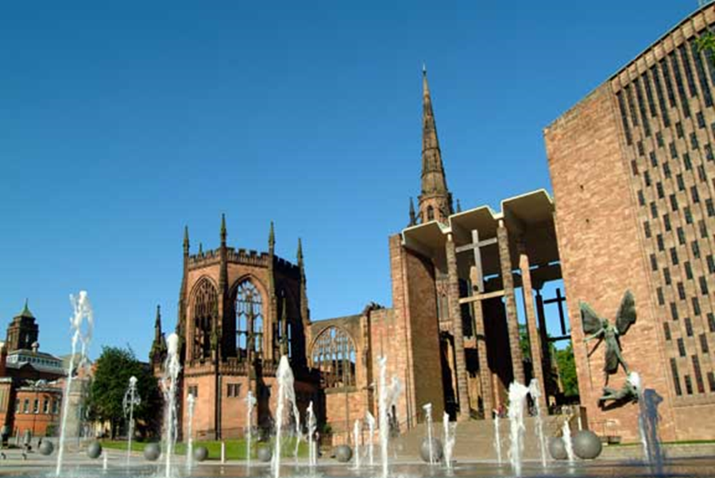

Contents

Background from the Dean

Job description

Person specification

Guidance on completing your application

Privacy notice and dealing with personal data

Dear Applicant,

Thank you for your interest in applying for the post of Executive Assistant at Coventry Cathedral. This is a vital post for us and has a key role in supporting our management and governance across the organisation. This role is wide ranging covering governance, HR, office administration and providing executive support to the Dean and the wider leadership team on a range of issues. You would contribute significantly to our organisation through this role.

Context

Coventry Cathedral is a living breathing space which welcomes worshippers, tourists, audiences and school children daily from near and far, either visiting or looking for place of sanctuary. With daily worship, and events taking place all year round, a busy tourist offer and a thriving education programme, all housed in the building coined “new cathedral” built in 1962. The Cathedral is also custodian of its predecessor- a 15th century building, destroyed and ruined in the Blitz during Nov 1940. The site and story have risen to international recognition, becoming a symbol and example of reconciliation. Both the new and Ruined Cathedral are grade 1 listed.

In 2023, in line with a change to legislation in April 2021, the Cathedral became a registered charity. This led to a complete overhaul of our governance and management systems and processes and, whilst much of this is now well established, there are elements that require refinement and further development.

About Us

The Cathedral team is made of approximately 35 permanent members of staff and a growing team of volunteers. With a broad variety of specialisms within the team we pride ourselves in working across these together to meet the various challenges which we face. To help you understand more about us, I have listed our strategic objectives and values below. I hope they will give you a flavour of us as an organisation.

Our Strategic Aims

- To be an open building that welcomes all people
- To have high quality and diverse opportunities for worship
- To be a local, national and international leader in reconciliation

These are delivered through a set of priorities:
- To see the Cathedral embedded as the spiritual heart of the city and diocese; as a place where people are reconciled to one another and to God
- To see the potential of our people released to share in the ministry of reconciliation
- To see our engagement with visitors shaped to focus on our reconciliation story
- To see exciting arts and events commissioned which further the journey towards reconciliation
- To see the Cathedral’s reconciliation networks developed to foster reconciliation locally, nationally and around the world
- To see the Cathedral’s journey progressed to becoming net-zero, reconciling us to the earth

Our Values

Hospitality – of both people and ideas
Faith and Spirituality – being open to the challenge and resources of God
Art and Creativity – expressing the life of God amongst us in ways beyond words
Risk Taking – confidently stepping out of the familiar in the service of God
Excellence – always reaching beyond our present practice and experience
Community – respecting and caring for one another

We are seeking someone who is in sympathy with our ethos as a Christian organisation at the heart of this great City. You do not need to be a practicing Christian. Our values drive and shape us and if you feel you could bring your skills, experience and expertise to help us achieve our vision and deliver our values, then we would love to hear from you.

I hope you find this information useful in preparing your application.

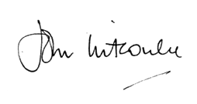
The Very Reverend John Witcombe MA MPhil
The Dean of Coventry

Job Description

Job Title: Executive Assistant
Hours: 28 hours – days and times flexible to be agreed with job holder
Salary: £18,475 (for 28 hours)
Reporting to: The Dean and Chief Operating Officer
Work base: The Cathedral and its offices
Date of Issue: May 2025

AIM
To provide administrative support to the Dean of Coventry and the wider Cathedral organisation to enable the Cathedral to fulfil its vision.

KEY RESPONSIBILITIES:
- To provide excellent broad administration support to the Dean including managing his diary.
- To deliver the governance processes of the Cathedral including coordination of agendas and papers for Chapter, keeping up to date policies and records in relation to those as required.
- To undertake general administration work in relation to Human Resources management including, collation and preparation of payroll information, preparation of job-related documents and recruitment information under the oversight of the Chief Operating Officer.
- To be lead user for online management systems including online HR system and training systems, payroll, diary and Harlequin CRM (In conjunction with the Fundraising team).
- To manage relevant data in the Customer Relationship Management system to ensure it is accurate, up to date and can be used effectively.
- To support general administration of the Cathedral e.g. responding to website queries, ordering stationery, preparing for meetings etc.

Dean’s Office Executive Assistance
- Support the Dean in his day to day work
- Manage the Dean’s diary and liaise with partners across the City and nationally / internationally to set up meetings as required
- Liaise and co-ordinate Cathedral-based civic events in conjunction with the Lord Mayor’s Office and Bishop’s House
- Prepare correspondence on the Dean’s behalf
- Set up meetings (refreshments, technology, rooms) as needed
- Prepare meeting papers and agendas as required
- Keep data in CRM system (Harlequin) up to date in relation to groups the Dean works with and the Electoral roll

Wider Cathedral Governance
- Maintain the Cathedral policy schedule and highlight aspects for review in good time
- Create and maintain records to ensure governance policies are being complied with (declarations of interest, review dates of policies and / or appointments etc)
- Support the preparation of agendas and papers for the primary governance committee meetings
- Work with the Dean’s Leadership Team to prepare AGM agenda and circulate papers

HR administration
- Work with the Chief Operating Officer to collate payroll information – collection of timesheets, completion of forms, processing leavers / starters etc. in readiness for the monthly payroll run
- As required prepare documents for recruitment or other HR processes, including uploading job advert on external sites and preparing applications for shortlisting
- Liaise with our outsourced provider (HRDept) in order to prepare contracts for new starters and coordinate all necessary documentation
- Undertake DBS and right to work checks as required for staff appointments
- Be responsible for ensuring records are up to date on HR Toolkit and identify gaps or problems, escalating them to the Chief Operating Officer as needed
- Create and register new users for our online HR systems
- Adhere to all Data Protection and recruitment policies
- Coordinate training courses as needed (Some face to face, some online).

General Administrative Support
- Respond/acknowledge receipt of correspondence on behalf of the Dean and others as and when required
- Coordinate responses to web enquiries as received
- Maintain the electoral roll on our CRM system
- Field incoming telephone calls to the Cathedral office
- Field incoming post for the office
- Order stationery
- Miscellaneous tasks as and when required

Terms and Conditions
- 28 hours per week.
- You will be working flexibly normally over 5 days per week with occasional weekends, early mornings and evening work required. The Cathedral operates time off in lieu for extra hours worked.
- A starting salary of £18475 (for 28 hours work) and 8% employer contribution pension scheme.
- 22 days annual leave (some of which will be compulsory) plus 8 public holidays. No additional payment or time off in lieu will be awarded for bank holiday working.

Person Specification
 | Essential | Desirable | Evidenced through
Interpersonal
Warm and friendly demeanour – willingness to help | X |  | Interview
Experience
Provision of broad administrative support in a busy office | X |  | Application
Using MS Office to a good standard | X |  | Application and test at interview
Using Outlook to manage the diaries of others effectively | X |  | Application
Of preparing contracts and official documents |  | X | Application and interview
Of using a CRM database system to manage personal data |  | X | Application and interview
Of operating efficient systems to manage information – filing, record keeping etc. | X |  | Application and interview
Knowledge
GDPR and requirements for managing data legally and confidentially |  | X
Understanding of the Church of England and the Cathedral environment |  | X
Skills
Organised and structured to ensure various timescales are met | X |  | Interview and test at interview
Clear communicator in person and on paper | X |  | Interview and test at interview
Ability to prioritise work to meet changing needs | X |  | Interview and test at interview
Use of Excel to create spreadsheets and graphs |  | X | Application and interview
Good numeracy skills | X |  | Application and Test at interview

Guidance on completing your application

All vacancies are accompanied by a job description and a person specification. The job description sets out the main duties and responsibilities of the post, and the person specification details the knowledge, skills and abilities we are looking for.

To apply for the post please send us a copy of your CV along with a covering letter of a maximum of 2 A4 pages telling us how you meet the criteria set out in the Person Specification. The covering letter is your opportunity to provide all the information we need to help us understand how you meet the requirements of the job, and plays an important part in the selection process allowing us to short-list candidates for interview and helping as a basis for the interview itself. Please use the covering letter to demonstrate how you meet the essential and desirable requirements of the person specification. Applications without a covering letter will not be shortlisted.

To ensure fairness to all applicants, short listing decisions are based solely on the information you supply on your CV and covering letter. Even if we already know you as current or previous employee, it is important that you complete the application process in full.

We operate a “Safer Recruitment” process, please ensure your CV lists two references. One of these should be from your current, or most recent, employer (this will be taken up at the point of job offer, but not without your permission).

Depending on the number of applications, it may not be possible to shortlist for interview all candidates who meet the Essential Criteria.

Please e-mail, your CV and covering letter to office@coventrycathedral.org.uk (please put the job title as the subject of the email), or send it by post to Recruitment, Coventry Cathedral, 11 Priory Row, Coventry, CV1 5EX.

Ensure you clearly state the full job title to which you are applying.

All applications must reach us on or before the closing date which is 12 Noon on Wednesday 11th June.

Interviews
Interviews are provisionally scheduled for Thursday 19th June.

Data Protection
Information provided by you as part of your application will be used in the recruitment process. Any data about you will be held securely with access restricted to those involved in dealing with your application and in the recruitment process. Once this process is completed the data relating to unsuccessful applicants will be stored for a maximum of 6 months and then destroyed. If you are the successful candidate, your CV and cover letter will be retained and form the basis of your personnel record. By submitting your CV you are giving your consent to your data being stored and processed for the purposes of the recruitment process, equal opportunities monitoring and your personnel record if you are the successful candidate.

Work Permits
Under the Asylum and Immigration Act, we are required to check that anyone taking up employment with us has the legal right to work in the UK. Short-listed applicants will be asked to provide us with documentary evidence to support their entitlement to work in the UK prior to any offer of employment being made.

References
In the event of an offer of employment being made, we will take up references and reserve the right to validate all information entered on the CV.

Questions?
If you have any questions or queries, please contact Simon Danks on 024 7652 1242 or email coo@coventrycathedral.org.uk.

Job Applicant Privacy Notice
COVENTRY CATHEDRAL (‘we’ or ‘us’) provide this notice to make job applicants aware of our policies relating to the processing of personal data in accordance with the Data Protection Act 1998 as amended, replaced, re-enacted or consolidated from time to time (including without limitation the General Data Protection Regulation (EU) 2016/679 and any national laws which relate to the processing of personal data (‘Data Protection Legislation’)) references to ‘Personal Data’ and ‘Sensitive Personal Data’ within this notice shall be references to those terms as defined in Data Protection Legislation.

Personal Data
We ask for Personal Data from job applicants including CVs and any ancillary information provided as part of your application to assist with our recruitment processes. Any Personal Data about you which is obtained by us during the application process (including any information obtained directly from you or from third parties such as your referees or as part of pre-employment checks) or as part of pre-employment checks may be retained and used by us for the purposes of considering your suitability for employment, conducting appropriate checks and as otherwise reasonably required for our legitimate interests and compliance with applicable law.
If your application is successful, and you subsequently become employed by us, the information described above will form part of your personnel file. If we do not employ you, we may still retain for up to 6 months so that we can consider you for future roles.

Sensitive Personal Data
You may also supply us with Sensitive Personal Data including but not limited to data relating to your racial or ethnic origin, religious or similar beliefs, physical or mental health and sexual orientation by completing our equal opportunities monitoring form. This information is gathered for equality of opportunity monitoring purposes and is anonymised. The provision of such Sensitive Personal Data by you is entirely voluntary.

If we receive information regarding any medical condition, disability, or relating to your physical or mental health including information provided within return to work forms, meetings or in medical reports, we will only use this information for the purpose of providing any necessary adjustments in accordance with equality legislation, to ensure compliance with employment law, to monitor sickness absence and to inform decisions regarding your fitness for work.

Staff Privacy Policy
For further information regarding the Personal Data we collect about you, how we use it, including disclosure to third parties, how we maintain security of your information and your rights to access the information we hold about you, please see our Staff Privacy Policy which is available from the Office Administrator.

