**Joining the Coventry Cathedral Chapter (non-Executive Trustee role - voluntary)**

**Candidate information Pack**

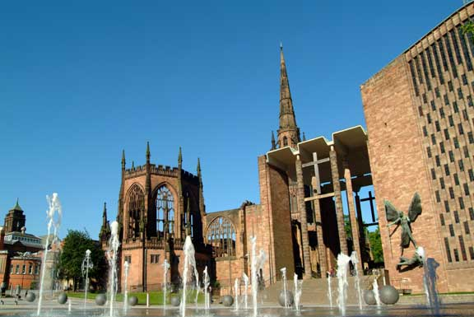

Dear Applicant,

Thank you for your interest in applying to be a member of the Chapter of Coventry Cathedral. This is a new trustee role as the Cathedral becomes a registered Charity. We have prepared some information below to help you find out more about the role and to decide if you would be interested in applying.

If you would like an informal conversation about the Chapter role then please email the Chief Operating Officer, Isabel Merrifield, on [isabel.merrifield@coventrycathedral.org.uk](mailto:isabel.merrifield@coventrycathedral.org.uk)

**Context**

Coventry Cathedral is a living breathing space which welcomes worshippers, tourists, audiences and school children daily from near and far, either visiting or looking for place of sanctuary. We have daily worship, and events taking place all year round, a busy tourist offer and a thriving education programme. All these activities are housed in the building coined the “new cathedral” built in 1962. The Cathedral is also custodian of its predecessor- a 12th century building, destroyed and ruined in the Blitz during Nov 1940. The site and story has risen to international recognition, becoming a symbol and example of reconciliation. Both the new and Ruined Cathedral are grade 1 listed.

We are working to implement changes which will see the Cathedral (along with all other English cathedrals) become a registered charity. This role is part of the new governance which we will be implementing during 2023.

**About Us**

The Cathedral team is made of approximately 30 permanent members of staff and a team of volunteers. With a broad variety of specialisms within the team we pride ourselves in working together across these to meet the various challenges which we face. To help you understand more about us, I have listed our strategic objectives and values below. I hope they will give you a flavour of us as an organisation.

**Diversity**

We recognise that our team of staff and volunteers is not as diverse as we would like it to be and does not yet reflect the vibrant diversity of our City. We would therefore encourage applications from people who may help us to become more diverse. We know a broader range of backgrounds and life experiences in our teams enriches us as an organisation.

**Our Strategic Objectives**

One of the first roles of the Chapter, when it is set up in its new form, will be to review and update our strategic plan. Our existing plan was scheduled to run until the end of 2022, but we extended it to enable our new trustees to have comprehensive input into it.

Our strategic objectives 2017 – 2022 were:

* *To confirm the Cathedral as the spiritual heart of the city and Diocese*
* *To grow the Cathedral congregations*
* *To secure the Cathedral as a tourist attraction, place of pilgrimage and of learning*
* *To confirm the Cathedral as a major regional venue for arts and events*
* *To facilitate and support the work of reconciliation with our partners locally, nationally and internationally*

*These are enabled through:*

* *Fit for purpose, well maintained campus and buildings*
* *Committed people including staff, volunteers congregation and other partners*
* *Effective communications within and beyond our present reach*
* *A sustainable financial base*

**Our Values**

**Hospitality** – of both people and ideas

**Faith** and **Spirituality** – being open to the challenge and resources of God

**Reconciliation** – embracing and welcoming difference and diversity

**Art** and **Creativity** – expressing the life of God amongst us in ways beyond words

**Risk Taking** – confidently stepping out of the familiar in the service of God

**Excellence** – always reaching beyond our present practice and experience

**Community** – respecting and caring for one another

Chapter members do need to be practicing Christians. Our values drive and shape us. If you feel inspired to bring your skills, experience and expertise to help us shape and achieve our objectives and deliver our values, then we would love to hear from you.

I hope you find this information useful in preparing your application.

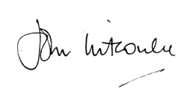

**Very Reverend John Witcombe, Dean of Coventry**

**Chapter role description**

The Chapter is the equivalent of a Board of Trustees for the Cathedral. Once the Cathedral has become a registered charity, then the Chapter will be the Board of Trustees. It is the administrative body of the Cathedral and has the ultimate responsibility for directing and overseeing its affairs.

The objects of the Chapter are—

1. to advance the Christian religion in accordance with the faith and practice of the Church of England, in particular by furthering the mission of the Church of England;
2. to care for and conserve the fabric and structure of the Cathedral Church building;

The Chapter is responsible for the governance, strategy and management of the Cathedral’s financial and other assets.

The Chapter consists of the Dean, the Residentiary Canons and other ordained and lay members holding appointed or elected positions. Its other members are non-Executive trustees drawn from a variety of organizations and backgrounds, its duty is to further and support the work of this Cathedral Church in delivering its vision in accordance with its values.

**Membership**

The constitution allows for between 8 – 12 members of Chapter. The Dean and the Residentiary Canons (3 clergy) are executive members. The Dean is the Chair of Chapter. There is a senior non-executive member who is a lay person appointed by the Bishop. There must also be a member with recent relevant finance experience who chairs the Finance Committee. Two of the remaining positions are directly elected from the congregation.

All members of Chapter must be Christians, but non-executive members do not necessarily need to be a member of the Church of England. Non-Executive Chapter members are generally appointed for a term of office of 3 years and no non-executive member may serve more than 3 consecutive terms of office.

**Meetings**

Chapter usually meets 11 times each year (with no meeting in August) in the last week of each month, generally on a Tuesday morning. Meetings are held in St Michael’s House beside the Cathedral and generally last around 2 hours.

Members of Chapter are expected to:

* Oversee the strategy of the Cathedral
* Engage in decision making with the executive of the Cathedral for the better delivery of the Cathedral’s mission, vision and objectives.
* Support other Cathedral activities as their particular skills determine

**Specific skills and qualities sought**

From an analysis of existing Chapter members, the Nominations Committee has identified the following skills and qualities as being really valuable to bring into our Chapter. If you don’t have these specifically, we would still be interested to hear from you as the make up of the group will continue to change and different skills may come to the fore.

* Change Management
* HR / Training / People Management
* Income generation / Fundraising
* Marketing / Social Media
* Diversity

**How do you apply?**

Interested individuals are requested to complete a simple application form outlining what they would bring to the Chapter and the Cathedral. The Application form is available on our website in our job opportunities section: [Job opportunities - Coventry Cathedral](https://www.coventrycathedral.org.uk/support-us/job-opportunities) or you can email [Office@coventrycathedral.org.uk](mailto:Office@coventrycathedral.org.uk) for a copy.

All Chapter Members will need to undertake safeguarding training and will need to complete a declaration about being a fit & proper person as well as to supply information on any potential conflicts of interest.